**Assignment 3 – Streamlit App**

**Link to app:** <https://appassignment-4rec6tsuoet8cq2cz6iljg.streamlit.app/>

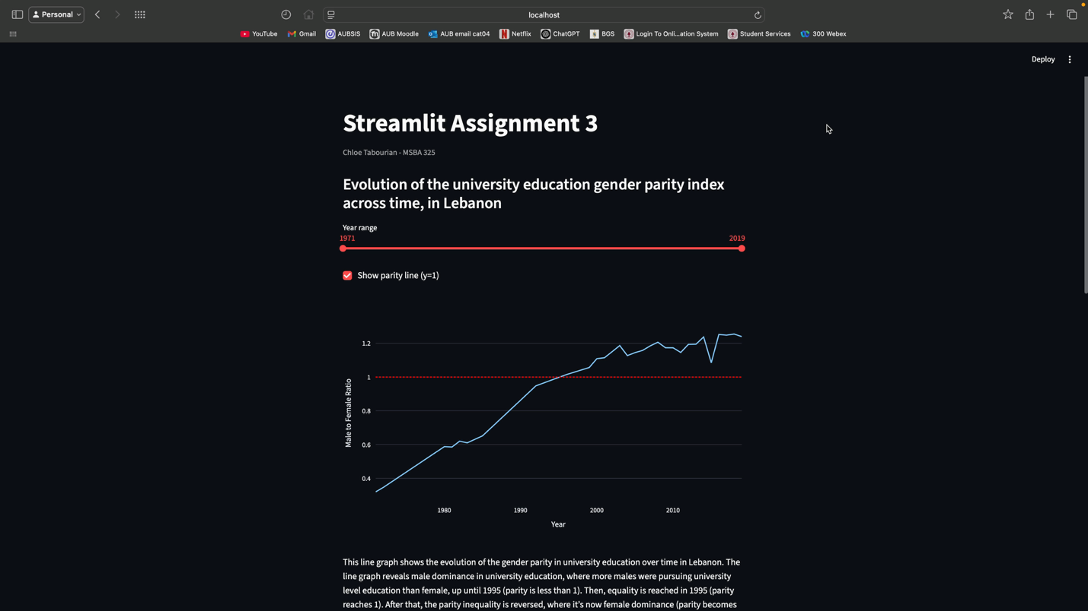**Video Presentation**

**Screenshots:**

**